INNOVA JUNIOR COLLEGE

JC 2 PRELIM EXAMINATION  
in preparation for General Certificate of Education Advanced Level  
**Higher 2**

CANDIDATE

NAME

CENTRE NUMBER INDEX NUMBER

**H2 COMPUTING 9597/02**

Paper 2 **28 August 2018**

**3 hours**

Additional Materials: Answer Paper

**READ THESE INSTRUCTIONS FIRST**

Write your Centre number, index number and name on all the work you hand in.

Write in dark blue or black pen on both sides of the paper.

You may use an HB pencil for any diagrams, graphs, tables or rough working.

Do not use staples, paper clips, glue or correction fluid.

DO **NOT** WRITE IN ANY BARCODES.

Answer **all** questions.

At the end of the examination, fasten your work securely together.

The number of marks is given in brackets [ ] at the end of each question or part question.

This document consists of 8 printed pages.

|  |  |  |  |
| --- | --- | --- | --- |
| final | Innova Junior College |  | **[Turn over** |

**[Turn over**

Answer **all** questions.

1. The Singapore Armed Forces is made up of many men and women who are committed to protect the nation’s peace and security. The Ministry of Defence (MINDEF) keeps detailed personnel records of all servicemen and servicewomen in a large database housed in the central server at MINDEF Headquarters. Personnel records include career history, salary, military rank, health details, achievements and awards.

The Human Resource Unit (HR) of MINDEF manages these records regularly through a computerised system. Updates of the personnel’s records must be done within three working days once HR receives the information from any military unit in MINDEF. Subsequently, administrative officers of the military units in MINDEF will be able to view these records via the intranet.

The current system has been used for the last fifteen years. MINDEF wishes to replace this system with a new computerised system with enhanced features and a better user interface. A system developer is employed to carry out the task.

MINDEF has accepted the proposal by the system developer, who will address the following problems with the current system:

1. Poor database design
2. Limited types of reports that can be generated
3. Lack of intuitiveness of the user interface
4. Slow system response time
5. Incompatibility with the current devices’ operating systems
6. Minimal security protection
7. The system developer produces the following Program Evaluation and Review Technique (PERT) chart:
8. Analysis of the solution
9. Design of the solution
10. Development of the solution
11. Documentation of the solution
12. Implementation of the solution
13. Testing of the solution

Time is measured in weeks.

A

B

C

D

E

F

3

12

13

8

4

5

From the PERT chart,

1. state the critical path. [1]
2. state the minimum time in which the project can be completed. [1]
3. describe and give an example of concurrent activities. [2]
4. describe and give an example of dependent activities. [2]
5. The system developer is required to provide more details in the PERT chart. It is proposed that Activity F should be removed from the chart and three new activities added:
6. Black box testing – 2 weeks
7. White box testing – 2 weeks
8. Beta testing – 3 weeks

Redraw the PERT chart to show the effects of these changes. [4]

1. Draw a sketch of the Gantt chart to show the information in **(a)**. [6]
2. Maintenance will be required after implementing the new system.

Describe **two** types of maintenance. For each type, give an example for this new system. [6]

1. The new system will provide all staff in HR with full access to all personnel records. The administrative officers of the military unit will have only read access to the data. Only designated computers in the MINDEF network are able to access the system.

Describe **three** ways in which the security of this system can be maintained. [6]

1. MINDEF is considering to allow servicemen and servicewomen to update their own personnel records directly into the system via the internet. Describe one **security** concern and one **ethical** issue that may arise due to this proposed implementation. [2]

**[Turn over**

1. A self-checkout counter of a local supermarket, PriceFare, allows customers to scan and pay for their groceries without the need for a human cashier. The customer interacts directly via the following user interface:

Tomatoes 4.96

Milk 5.50

Potatoes 3.43

Sushi 8.50

Rice 10.50

**Total $32.89**

**Proceed to Payment**

**Scan your items one at a time.**

Key in Code

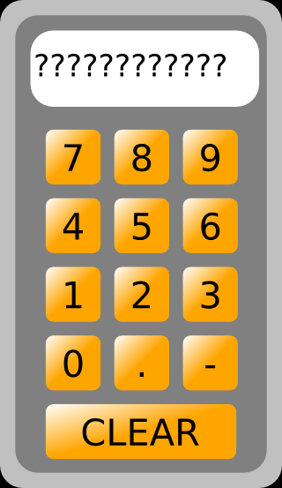

Help

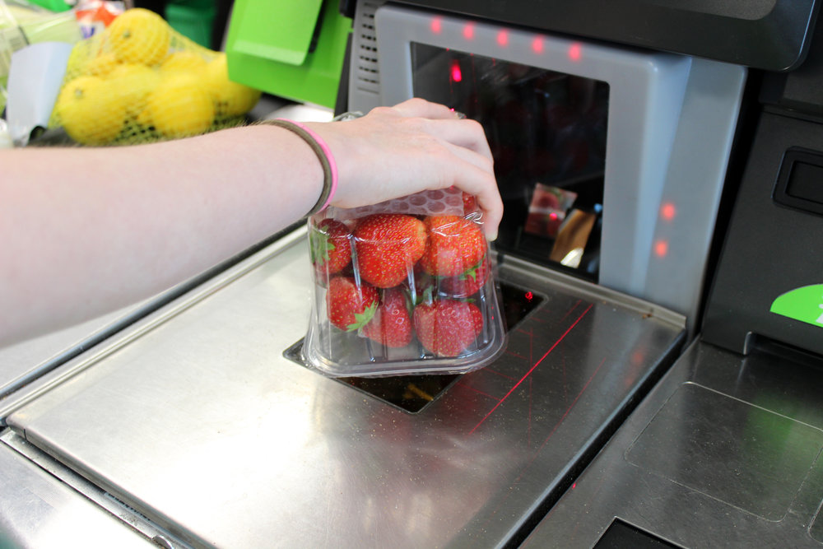

1. State the type of user interface being used. [1]
2. Name **two** user input methods for the user interface. [2]
3. Identify **one** feature of the user interface and explain the design consideration involved in the choice of this feature. [3]

“Many people confuse the Internet as cloud computing”.

1. Explain how the Internet and cloud computing are different. [2]

PriceFare intends to launch an online service in Singapore. Customers can purchase their groceries using a mobile application anywhere in Singapore. The management of PriceFare is deciding between two different types of cloud services for this project – Platform as a Service (PaaS) and Infrastructure as a Service (IaaS).

1. Describe the differences between PaaS and IaaS. [2]
2. What should the management of PriceFare consider when choosing between these two types of cloud services? [2]
3. Give a reason why Software as a Service (SaaS) is not considered by the management of PriceFare. [1]
4. The following table shows a partial list of Unicode characters.

|  |  |  |  |
| --- | --- | --- | --- |
| **Unicode** | **Character** | **Denary Value** | **Description** |
| U+0393 | Γ | 915 | Greek Capital Letter Gamma |
| U+0394 | Δ | 916 | Greek Capital Letter Delta |
| U+0395 | Ε | 917 | Greek Capital Letter Epsilon |
| U+0396 | Ζ | 918 | Greek Capital Letter Zeta |
| U+0397 | Η | 919 | Greek Capital Letter Eta |
| U+0398 | Θ | 920 | Greek Capital Letter Theta |
| U+0399 | Ι | 921 | Greek Capital Letter Iota |
| U+039A | Κ | 922 | Greek Capital Letter Kappa |

1. Explain why the Unicode encoding system has replaced ASCII. [2]
2. The Greek capital letter Omega, ‘Ω’, has denary value 937. Write down its corresponding Unicode. [1]
3. Write down the 16-bit binary value of the Unicode character with Unicode U+0A6C7. [1]

The following pseudocode for a sort algorithm is used to sort a list of Greek character names.

01 FOR i 🡨 2 TO ArraySize:

02 Key 🡨 Array[i]

03 j 🡨 i-1

04 WHILE (j > 0) and (Key < Array[j])

05 Array[j+1] 🡨 Array[j]

06 j 🡨 j-1

07 ENDWHILE

08 Array[j+1] 🡨 Key

09 ENDFOR

The sort algorithm is used on Array, a list of 5 Greek character names.

|  |  |  |  |  |  |
| --- | --- | --- | --- | --- | --- |
| Array | Gamma | Delta | Epsilon | Zeta | Eta |

1. Write down the name of this sort algorithm. [1]

**[Turn over**

1. Copy and then complete the trace table given below. [6]

|  |  |  |  |  |  |  |  |
| --- | --- | --- | --- | --- | --- | --- | --- |
| Array | | | | |  | | |
| [1] | [2] | [3] | [4] | [5] | i | j | Key |
| Gamma | Delta | Epsilon | Zeta | Eta |  |  |  |
|  |  |  |  |  |  |  |  |
|  |  |  |  |  |  |  |  |
|  |  |  |  |  |  |  |  |
|  |  |  |  |  |  |  |  |

1. State the efficiency, in terms of running time, of this sort algorithm if the Greek character names in Array are initially in reverse order. [1]
2. A large file is to be transmitted between two computers over the internet.
3. Explain how packet switching is used to transmit the file over the internet. [3]
4. The bytes that make up a packet is checked by the receiving computer. Explain how this can be done for:
   1. The individual bytes which make up the packet [2]
   2. The collection of bytes which makes up the packet. [2]

Each packet consists of:

* + A 3-digit number from 100 to 800
  + Upper case letters
  + The <space> character
  + A start character ($) and an end character ($).

An example of a packet is:

$TBHIKR 565 KUTGW$

1. Explain the difference between data validation and data verification. [2]
2. Describe **three** validation checks that the receiving computer should perform on each packet received. [6]
3. The following security advisory was issued after the recent cyberattack on SingHealth’s IT system.

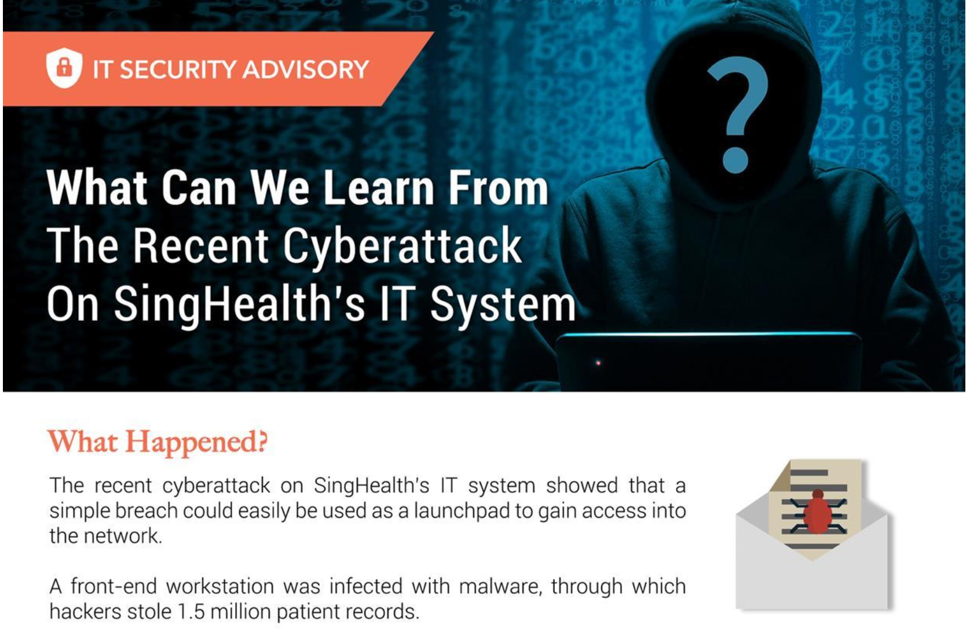

Source: Information Technology Branch, MOE.

Employees of SingHealth’s group of hospitals are issued with computing devices, which have access to patients’ records stored on the SingHealth central server, via the internet. Each employee is also issued with an email account for both internal and external communications.

1. Describe **two** differences between a client-server network and a peer-to-peer network. [4]

“*… a simple breach could easily be used as a launchpad to gain access into the network.*”

1. Describe how a breach could have happened and how patient records were subsequently accessed. [4]

A further notice adds that *“Employees can practice good personal data protection and cybersecurity habits in their place of work.”*

1. Describe **two** ways that this can be done. [2]
2. List **two** ways that SingHealth as an organisation can do to ensure the security of their network. [2]

**[Turn over**

1. The Singapore Bowling Federation (SBF) is made up of several affiliate clubs. To participate in a competition, a competitive bowler is required to be enrolled in exactly one affiliate club. A relational database is used by SBF to store data about competition entries and results. Four tables present in the database are CLUB, MEMBER, COMPETITION and COMPETITION-MEMBER. A new row is created in the COMPETITION-MEMBER table whenever a competitive bowler registers for a competition. When the competition results become available, they are added to the appropriate row.

Each competitive bowler, affiliate club and competition has a unique identification number.

1. Explain what a relational database is. [2]
2. Draw the Entity-Relationship (E-R) diagram to show the relationship between the four tables that provide for a fully normalised database design. [4]
3. A table description can be expressed as:

Tablename (Attribute1, Attribute2, Attribute3, …)

The primary key is indicated by underlining one or more attributes.

Write the table descriptions for the four tables. You should include at least **one** other attribute in addition to the primary key. [8]

1. Give **two** examples of data anomaly and describe how they may occur if the database that was designed for SBF was not fully normalised. [4]

**End of Paper**